**OUTDOOR MIST FANS:**

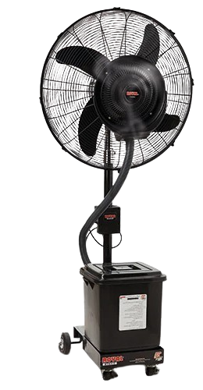

**Price: 18,000.00**

The Outdoor Mist Fan is a durable and weather-resistant cooling solution, designed to provide refreshing relief in outdoor spaces such as patios, decks, and pool areas. With its powerful fan and fine misting system, this fan effectively lowers temperatures and creates a cooling oasis, perfect for warm weather entertaining and relaxation. Its rust-resistant coating, UV-protected components, and easy mobility ensure reliable performance and low maintenance, making it an ideal choice for outdoor cooling needs.

**Key features of outdoor mist fans include:**

* **Misting Function**: Delivers a fine mist for cooling the air, reducing heat.
* **Weather-Resistant**: Built to withstand outdoor conditions like rain and humidity.
* **Powerful Airflow**: Provides strong airflow for large outdoor areas.
* **Adjustable Fan Speed**: Allows control over the intensity of airflow.
* **Oscillation**: Ensures even distribution of air and mist across a wider area.
* **Portable Design**: Easy to move to different outdoor locations.
* **Energy Efficient**: Uses less energy compared to air conditioning.
* **Large Water Reservoir**: Supports extended misting without frequent refills.
* Top of Form

Bottom of Form